PRESS RELEASE

Kverneland Group and Kubota Corporation are entering the
growing market for mergers by acquiring 80% of the shares in ROC, a leading company in this market segment

8 October 2021, Klepp, Norway.

Kverneland Group, a leading international company developing, producing and distributing agricultural machinery and services, announced today that it has signed an agreement to acquire 80% of the shares in the ROC Company, a leading producer of mergers located in Italy.

Mr. Shingo Hanada (President & CEO of Kverneland Group) is pleased to confirm that the ROC Company is further strengthening Kverneland - and Kubota Group’s strategic commitment to hay and forage harvesting, by adding the important merger product line and achieving synergies between the companies.

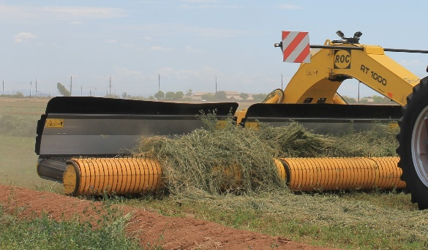

Further, Mr. Hanada is stating that the ROC distribution partners and customers are an important asset, and he confirms the continuation of the ROC brand and its distribution.

Both the current owners of the ROC Company, Mr. Denis Ubaldi and Mr. Raffaele Ubaldi, are continuing their important roles in the company after the transaction.

The Ubaldi brothers: “We see great opportunities and synergies in becoming part of Kverneland- and Kubota Group. Being part of this Group with a strong global footprint offers important strengths in many areas such as product development, manufacturing and not least in the important further digitalisation of farming systems and solutions”.

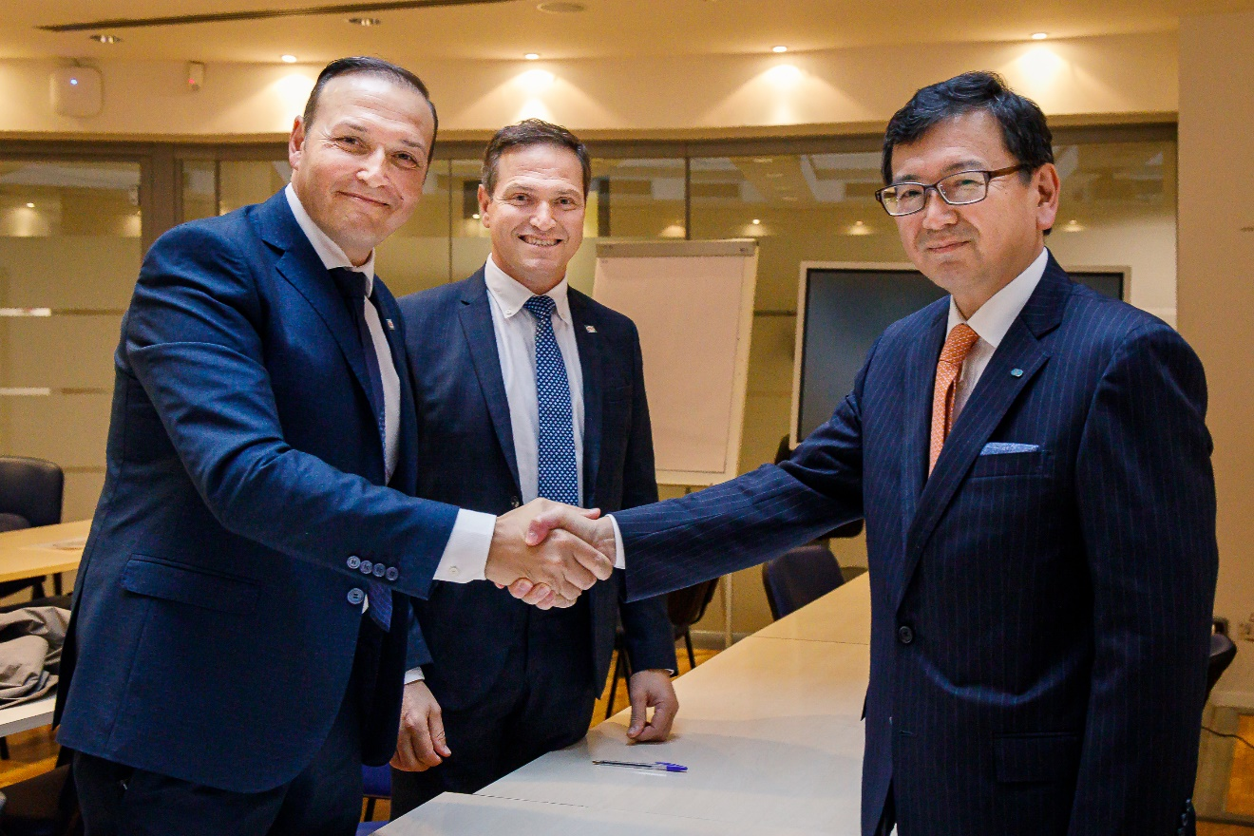

Mr. Denis Ubaldi, and Mr. Raffaele Ubaldi, owners of ROC. confirm the agreement with Mr. Shingo Hanada, President & CEO of Kverneland Group

Furthermore, the Ubaldi brothers are convinced that this deal will further strengthen ROC and its ability to grow and deliver attractive products, solutions, and support to their distribution partners and customers.

***

About Kubota

Kubota has been a leading manufacturer of agricultural, turf and construction equipment and Industrial Engines since 1890. With world Headquarters in Osaka Japan, offices in more than 120 countries, and with over 41,000 employees throughout North America, Europe and Asia, Kubota achieved revenues in 2020 of $17.3 billion. Kubota has worked closely with farmers to develop agricultural machinery with the aim to accelerate innovation to solve issues related to food, water, and the environment. Although agricultural equipment is Kubota’s primary line of products, Kubota also produces a diverse portfolio of other products including pipe-related products, environment-related products, and social infrastructure-related products to contribute to improve human lives and society. www.kubota.com

About Kverneland Group

Kverneland Group is a leading international company developing, producing and distributing agricultural implements, electronic solutions and digital services. Productivity, efficiency, and sustainability are three important principles in today's agriculture, driving us every day to continuously develop our Agricultural Implement Technology. Kverneland Group offers an innovative range of soil and seeding equipment, forage and bale equipment, spreading, spraying, electronic solutions and digital farm services for agricultural tractors and implements. For more information on Kverneland Group, visit www.kvernelandgroup.com

About ROC

ROC is a global pioneer in the development and manufacturing of mergers with leading positions across the world covering around 40 countries. The company is particularly strong in the high-end of the market and has expanded to a full range for the customers using mergers. High quality and performance is a core focus of the company, giving them a competitive advantage. The high level of vertical integration in manufacturing is essential for the quality of the ROC products, visit www.roc.ag

- - END - -
Download ROC image 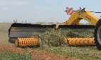

For information, Contact:

Claus Udengaard Thomsen, EVP Harvesting System Division
claus.udengaard.thomsen@kvernelandgroup.com

Arild Gjerde, EVP Sales & Marketing
arild.gjerde@kvernelandgroup.com

Kverneland Group on Social Media
 | Kverneland  Vicon  iM FARMING |  | @KvernelandGroup  @iM_Farming |  | kvernelandgrp |  | Kverneland  Vicon |  | Kverneland Group

